HOW TO SOLVE THE EXERCISE:
- Start from the entity set that do not have complex relationship with other entity set

Exercise 1

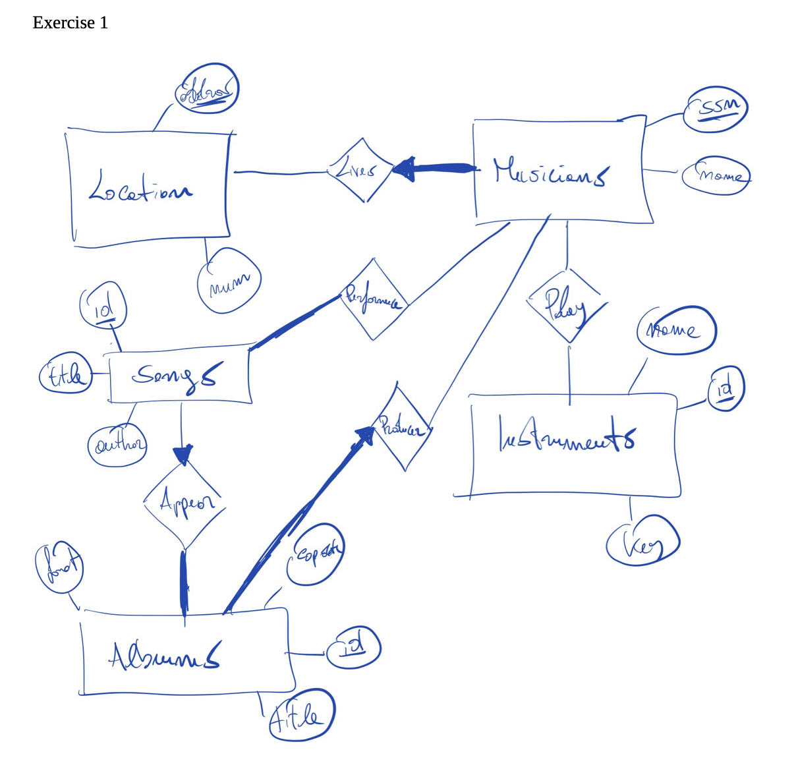

CREATE TABLE instruments (
id BIGINT GENERATED ALWAYS AS IDENTITY,
name VARCHAR,
mkey VARCHAR, --musical key
PRIMARY KEY (ID)
);

CREATE TABLE locations (
address VARCHAR,
num VARCHAR, -- phone number
PRIMARY KEY (address)
);

---
NOTE: is better to store phone numbers as VARCHAR rather than INTEGER for few reasons
- They are not used for mathematical operations and are treated as character data
- With VARCHAR you can store not only number but also characters such as + / and ()
- More flexible for international phone number formats (if necessary)
- INTEGER would force to remove non-numeric characters, and a phone number like +1 (555) 123-4567 would not be able to be stored
- INTEGER is typically used to store whole numbers that needs to be used in mathematical calculations

If you care about prefixes you could split the number in two parts: prefix and actual phone number.
---

CREATE TABLE musicians (
ssn VARCHAR,
name VARCHAR,
m_adress VARCHAR NOT NULL, -- should be the same time of the key of location (aka address)
PRIMARY KEY (ssn),
FOREIGN KEY (m_adress) REFERENCES locations
);

---
NOTE: with NOT NULL we were able to encode the relationship living because we specify that a musician must live in exactly one location. This happens because the primary key of location is address (and so there can not be two or more times the same address).
---

CREATE TABLE play (
mus_ssn VARCHAR, -- must be same type of the ssn in musicians
ins_id BIGINT, -- must be same type of id in instruments
PRIMARY KEY (mus_ssn, ins_id),
FOREIGN KEY (mus_ssn) REFERENCES musicians,
FOREIGN KEY (ins_id) REFERENCES instruments
);

---
NOTE:
- play is a many-to-many relationship
- Is better to change the attributes with different names, do not use ssn in play (there is already in musician) but instead use ins_ssn so that we specify the tables involved in this relationship
---

CREATE TYPE my_format AS ENUM (‘DVD’ , ‘BD’, ‘CD’, ‘VINIL’);

CREATE TABLE albums (
id BIGINT,
title VARCHAR,
format my_format, -- we defined a format before
copyright VARCHAR,
prod_ssn VARCHAR NOT NULL, -- not null so we know it is exactly one
PRIMARY KEY (id),
FOREIGN KEY (prod_ssn) REFERENCES musicians
);

---
NOTE: we use my_format so that people avoid writing the same thing in different ways (blue-ray, blueray, BlueRay, …)
---

CREATE TABLE songs (
id BIGINT,
title VARCHAR,
author VARCHAR,
album_id BIGINT, -- not use NOT NULL so it is at most one
PRIMARY KEY (id),
FOREIGN KEY (album_id) REFERENCES albums
);

CREATE TABLE performance(
song_id BIGINT,
mus_ssn VARCHAR,
PRIMARY KEY (song_id, mus_ssn),
FOREIGN KEY (song_id) REFERENCES songs,
FOREIGN KEY (mus_ssn) REFERENCES musicians
);

Exercise 2

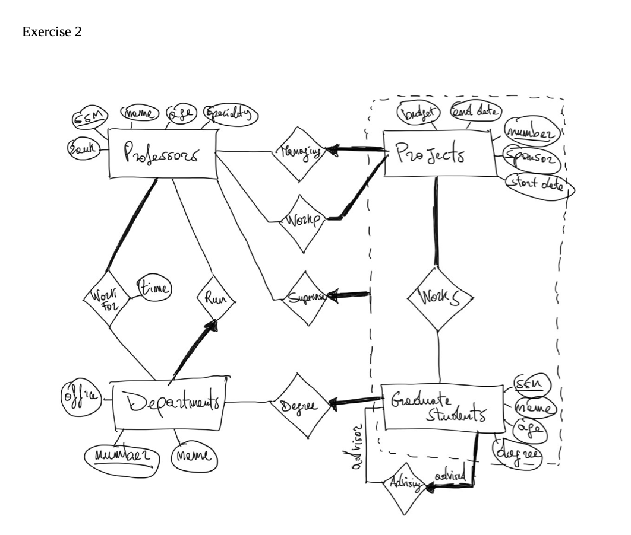

CREATE TABLE professors (
ssn VARCHAR,
name VARCHAR,
birthday DATE, -- use format date
speciality VARCHAR
rank INTEGER,
PRIMARY KEY (ssn)
);

CREATE TABLE projects (
number BIGINT,
budget BIGINT,
end_date DATE,
sponsor VARCHAR,
start_date DATE,
manager_ssn VARCHAR NOT NULL -- exactly one (managing relationship)
PRIMARY KEY (number)
FOREIGN KEY (manager_ssn) REFERENCES professors
);

CREATE TABLE departments (
number BIGINT,
office VARCHAR,
name VARCHAR,
director_ssn VARCHAR NOT NULL, -- exactly one (run relationship)
PRIMARY KEY (number),
FOREIGN KEY (director_ssn) REFERENCES professors
);

CREATE TABLE work_for_dept (
prof_ssn VARCHAR,
dept_num BIGINT,
time INT, -- hours of work
PRIMARY KEY (prof_ssn, dept_num),
FOREIGN KEY (prof_ssn) REFERENCES professors,
FOREIGN KEY (dept_num) REFERENCES departments
);

CREATE TABLE work_for_project (
prof_ssn VARCHAR,
proj_num BIGINT,
PRIMARY KEY (prof_ssn, proj_num)
FOREIGN KEY (prof_ssn) REFERENCES professors
FOREIGN KEY (proj_num) REFERENCES projects
);

CREATE TABLE grad_students (
ssn VARCHAR,
name VARCHAR,
birthday DATE,
following_degree VARCHAR, --
departmenet_num_of_degreee BIGINT NOT NULL, -- exactly one (degree relationship with departments)
advisor_ssn VARCHAR
PRIMARY KEY (ssn), -- use AT MOST ONE
FOREIGN KEY (departmenet_num_of_degreee ) REFERENCES departments
FOREIGN KEY (advisor_ssn) REFERENCES grad_students -- foreign key with itself (advisory relationship)
);

---
NOTE: we did not use EXACTLY ONE relationship for the advisory because it will loop forever (a graduate student must have exactly one graduate student as advisor, but the graduate student must have a graduate student as advisor, …) the loop never stops.
To avoid this we do not use EXACTLY ONE but instead we use AT MOST ONE, so we do not use NOT NULL for advisor_ssn
---

CREATE TABLE students_works_projects (
students_ssn VARCHART,
proj_num BIGINT,
supervisor_ssn VARCHAR NOT NULL -- for aggregation
PRIMARY KEY (students_ssn, proj_num)
FOREIGN KEY (students_ssn) REFERENCES grad_students,
FOREIGN KEY (proj_num) REFERENCES projects,
FOREIGN KEY (supervisor_ssn) REFERENCES professors
);

Exercise 3
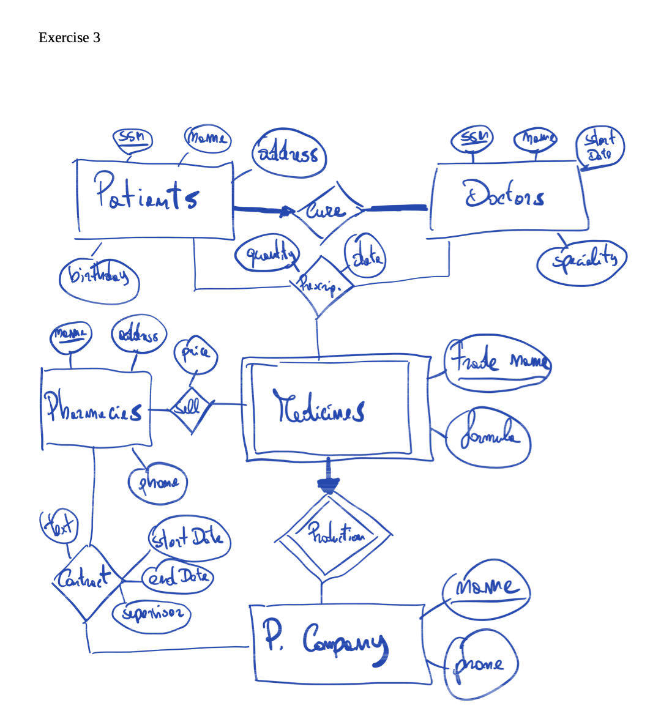

CREATE TABLE p_companies (
name VARCHAR,
phone VARCHAR,
PRIMARY KEY (name)
);

--- WEAK ENTITY SET ---

CREATE TABLE medicines (
trade_name VARCHAR,
formula VARCHAR,
producing_company VARCHAR
PRIMARY KEY (trade_name, producing_company)
FOREIGN KEY (producing_company) REFERENCES p_companies ON DELETE CASCADE
);

---
NOTE:
- in producing_company we should specify NOT NULL but in this case is redundant because producing_company is a key and so can not be null.
- We use ON DELETE CASCADE because if the value in p_companies disappear than we need to delete also the medicines
---

CREATE TABLE patients (
ssn VARCHAR,
name VARCHAR,
address VARCHAR,
birthday DATE,
PRIMARY KEY (ssn)
);

CREATE TABLE doctors (
ssn VARCHAR,
name VARCHAR
start_date DATE,
speciality VARCHAR,
PRIMARY KEY (ssn)
);

--- THREE WAY RELATION ---

CREATE TABLE prescriptions (
p_ssn VARCHAR, -- patients ssn
d_ssn VARCHAR, -- doctor ssn
med_trade_name VARCHAR,
med_company VARCHAR -- because the medicine name is weak constraint so it needs p_company
quantity INTEGER,
prescr_date DATE,

PRIMARY KEY (p_ssn, d_ssn, med_trade_name, med_company),
FOREIGN KEY (p_ssn) REFERENCES patients,
FOREIGN KEY (d_ssn) REFERENCES doctors,
FOREIGN KEY (med_trade_name, med_company) REFERENCES medicines
);

Exercise 4
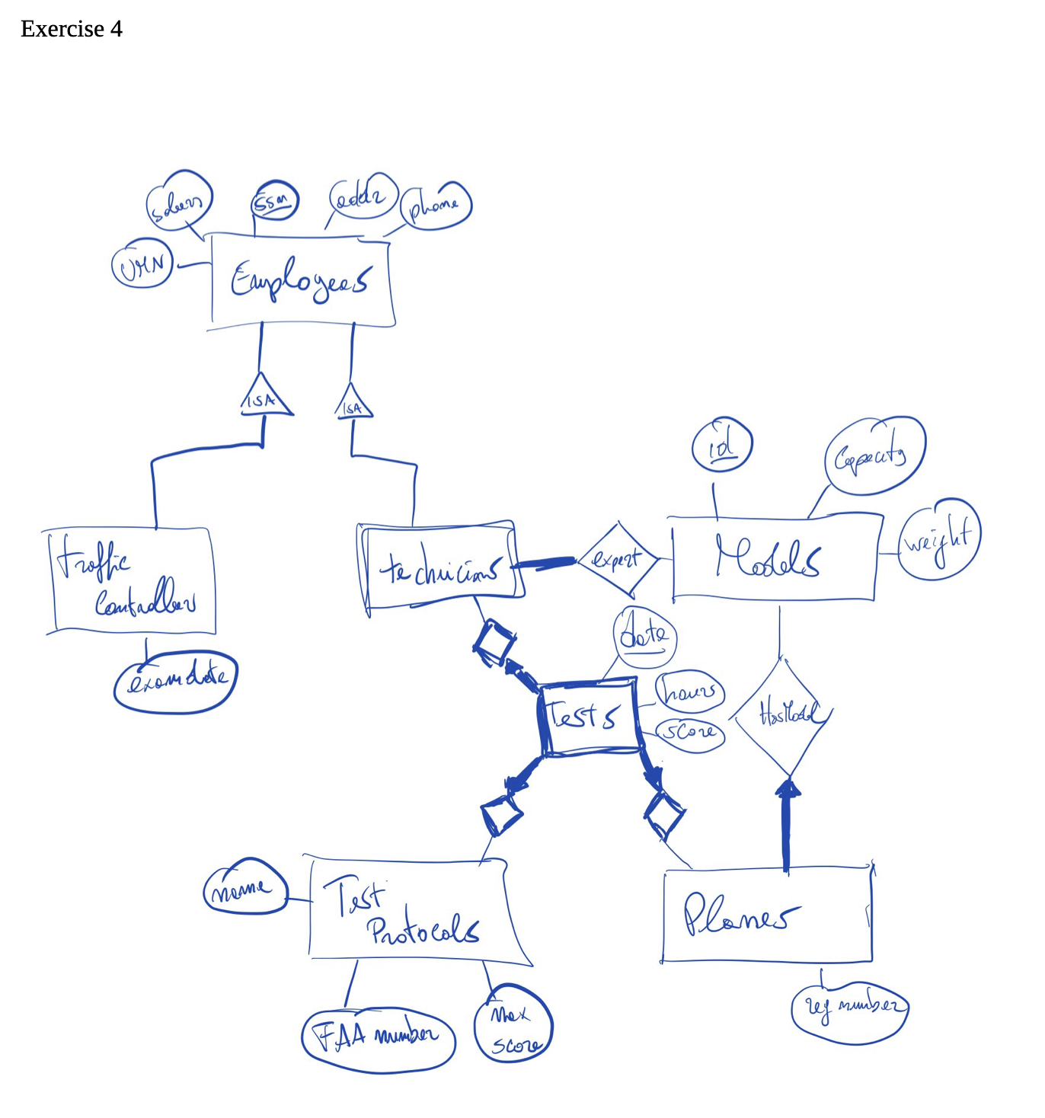
NOTE: if we do not specify anything there is
- NO COVER → we can have employees that are neither traffic controllers nor technicians.
- NO OVERLAP → we cannot have an employee that is both a traffic controller and technician.

--- NO COVER, NO OVERLAP ---
⟹ can use a new attribute for the employee entity set that allow to choose between ‘e’, ‘tr’, ‘tc’. But in this case it is not a good solution because tc have other relationships that ‘e’ and ‘tr’ do not have.

⟹ Another solution is a table for each subclass, the (small) problem is that we have to repeat every attribute of the master class (aka employees) in both traffic controllers and technicians. But a bigger issue is that we would have covering (an individual must be either traffic controller or technicians)

⟹ We will have a trade-off and we chose to have covering (so an employee can be two type at the same time).

CREATE TABLE employees (
ssn VARCHAR,
salary BIGINT,
address VARCHAR,
phone VARCHAR,
umn VARCHAR,
PRIMARY KEY (ssn)
);

CREATE TABLE traffic_controllers (
ssn VARCHAR, -- same of the employees, but we do not copy all the other attributes
exam_date DATE,
PRIMARY KEY (ssn),
FOREIGN KEY (ssn) REFERENCES employees
);

CREATE TABLE technicians (
ssn VARCHAR,
PRIMARY KEY (ssn),
FOREIGN KEY (ssn) REFERENCES employees
);

---

CREATE TABLE models (
id VARCHAR,
capacity INTEGER,
weight INTEGER,
PRIMARY KEY (id)
);

CREATE TABLES tests (
id BIGINT,
test_date DATE,
hours INT,
score INT,
tech_ssn VARCHAR,
plane_num BIGINT,
faa_number BIGINT,
PRIMARY KEY (id),
UNIQUE (technicial_ssn, plane_num, test_date) -- ensures that all values in a column are different
FOREIGN KEY (tech_ssn) REFERENCES technicians,
FOREIGN KEY (plane_num) REFERENCES planes,
FOREIGN KEY (faa_number) REFERENCES test_protocols
);

